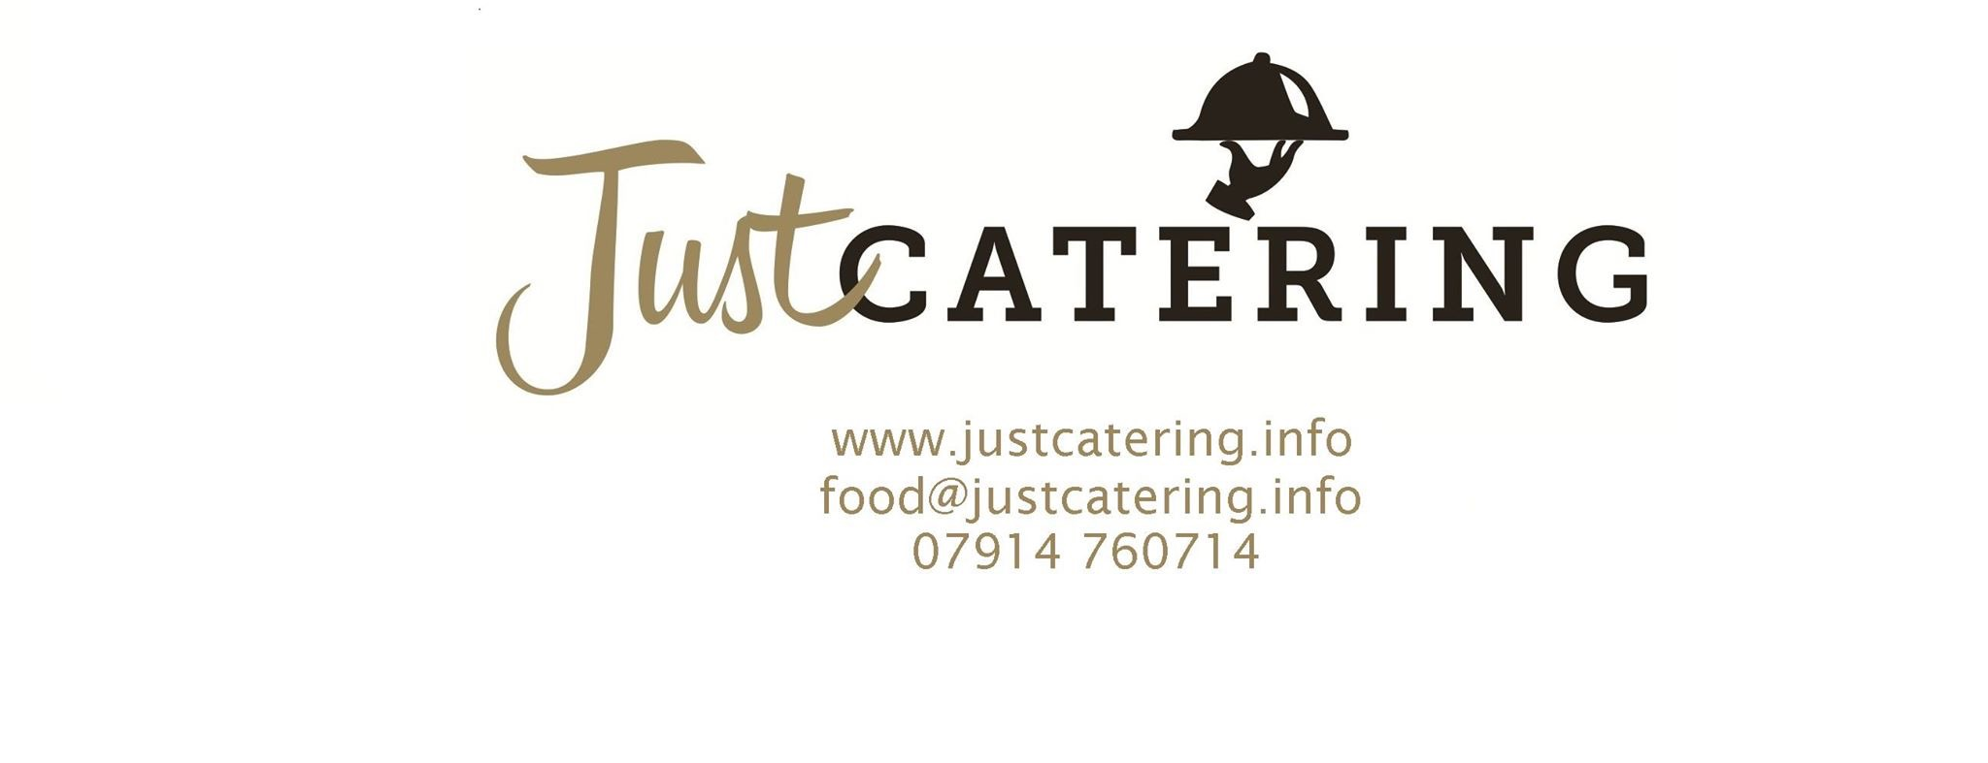

**Festive Menu 1**

**£8.95 per person**

Our festive menu gives guests a wide selection of festive buffet food. It includes a mixture of sandwiches and canapés as listed in the tables below.

We offer the opportunity to add a **cheese board** to this menu. This is £17.50 per 7 people, and includes a wide selection of cheese and crackers.

|  |  |  |
| --- | --- | --- |
| **A Sandwich or Wrap Selection**  The menu includes a selection of sandwiches on a mixture of malted and white bread. The fillings that are included are listed below.  If you would prefer, sandwiches can be prepared on plain wraps. | | |
| **Meat** | **Fish** | **Vegetarian** |
| * Roast turkey with cranberry and stuffing. * Roast beef with mustard OR horseradish. * Best cut of honey glazed ham. * Peri-peri chicken with red onion,cabbage and grated carrot salad. | * Smoked salmon with cream cheese and dill. | * Mature cheddar cheese and sweet chutney. * Mixed cheese and red onion with chives. * Brie and grape |

**AND**

|  |  |  |
| --- | --- | --- |
| **A Canape Selection**  The menu includes a selection of canapés as listed below. | | |
| **Meat** | **Fish** | **Vegetarian** |
| * Mini Yorkshire Puddings filled with beef and topped with horseradish. * Bacon and sausage wraps. * Marinated chicken skewers. | * Vol au vents filled with cream cheese and King prawns. | * Honey roasted parsnip and carrot purée filled vol au vents. * Vegetable spring rolls. * Feta cheese, olive and tomato skewers. * Carrot and cucumber batons with assorted dips. |

**AND**

|  |
| --- |
| **A Selection of Petit Fours**  To end your meal, we provide a selection of sweet petit fours listed below. |
| * Pistachio rectangles * Lemon macaroon tartlets * Raspberry tartlets * Chocolate eclairs * Coffee eclairs * Caramel squares * Praline tartlets * Morello cherry and pistachio moelleux * Opera rectangles |